**User Interface Design**

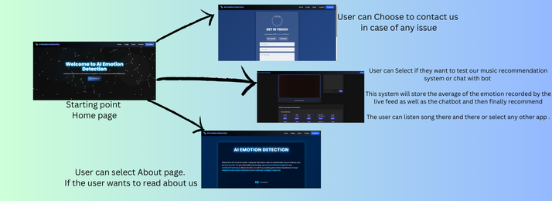

**Fig1. Overall Display**

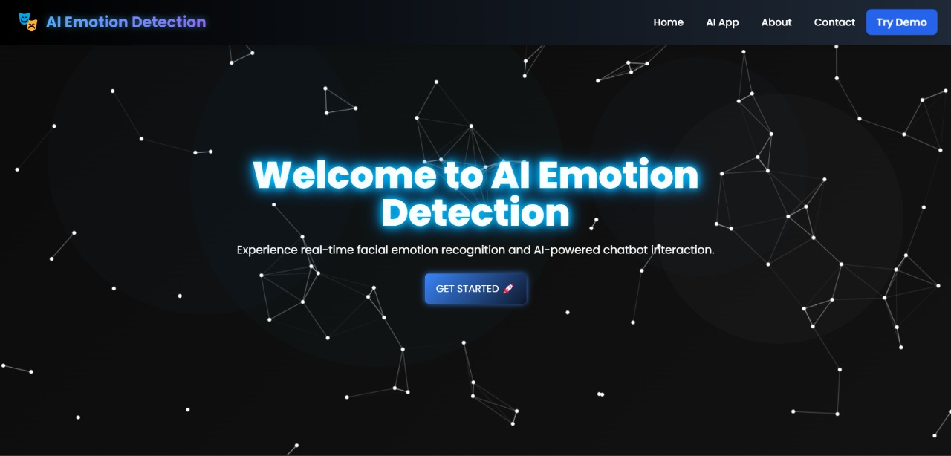

**Starting point /Home page**

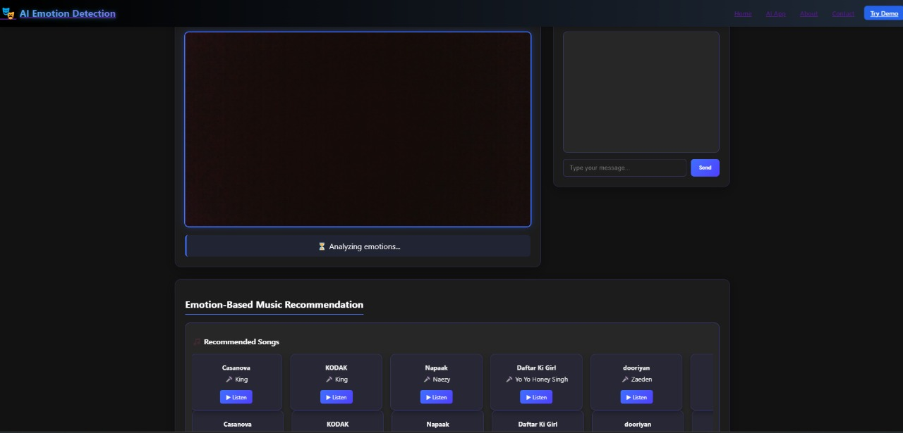

**Main Functionality**

* **User can Select if they want to test our music recommendation system or chat with bot**
* **This system will store the average of the emotion recorded by the live feed as well as the chatbot and then finally recommend**
* **The user can listen song there and there or select any other app.**

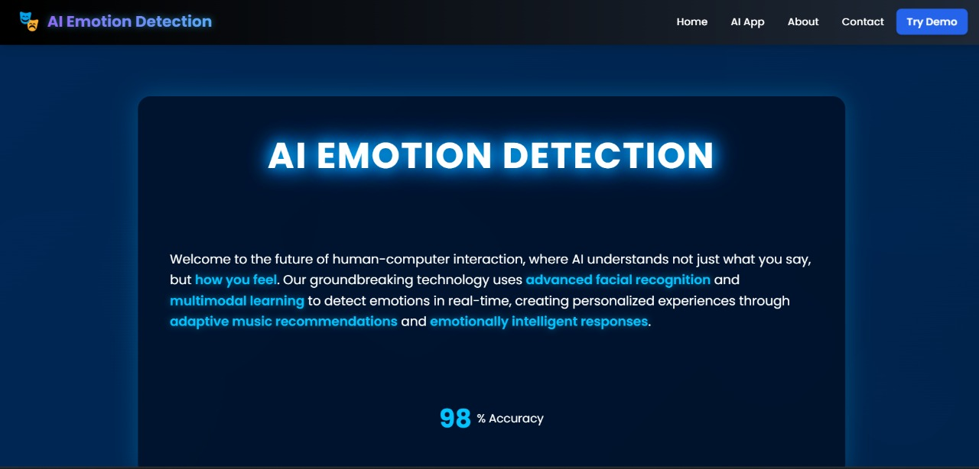

**User can select About page.**

**If the user wants to read about us.**

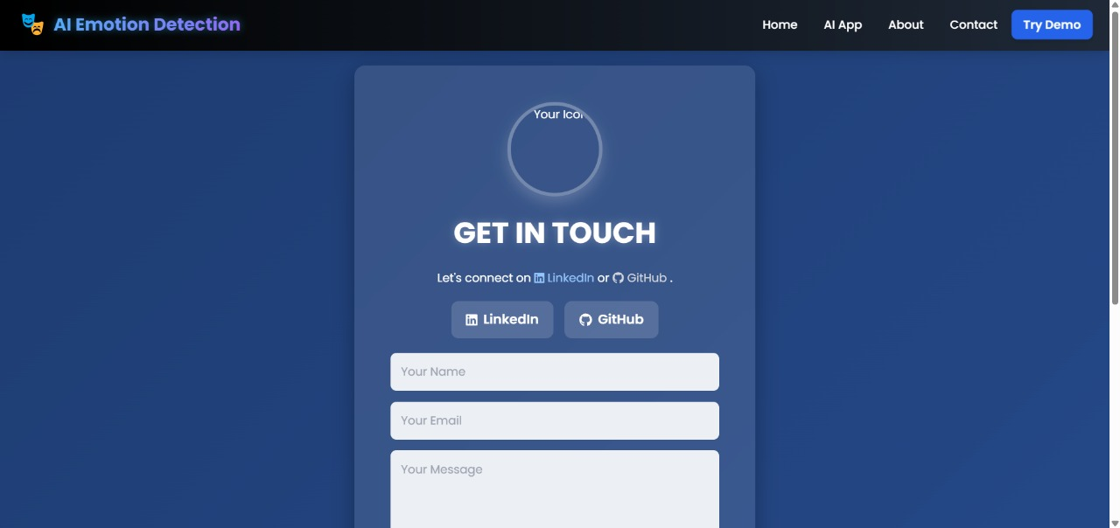

**User can Choose to contact us**

**in case of any issue**

1.)Our AI-based Emotion Detection and Music Recommendation System focuses on User-Centred Design by ensuring easy interaction, neat navigation, and good experience overall. The homepage includes a clear screen layout and other stuff. On another webpage AI_APP, one side displays live facial emotion recognition, while the other has an AI chatbot that utilizes GROQ’s API. Both run simultaneously without causing issue for the user. Detected emotions and chat history are processed in the background, and song recommendations appears on the frontend based on the user's emotional state which was predicted by the chatbot and live feed, ensuring responsive design and relevance. Features like real-time feedback, minimal clicks, smooth transitions, improve usability and engagement. This is how it meets the characteristics of User-Centred Design.

2.)

**Potential User 1 Feedback (Yajat Sharma, Class 9, Brother):**

**He said the website is really cool and neat. He added, he loves it because how it can just recommend songs on the basis of mood which is captured by the camera. He also said that the part where songs pop ups is his favourite part. He recommended me to add some more colours and animation to make it appealing to the students of his age.**

**Potential User 2 Feedback (Manish Kumar Sharma, Father):**

**My father gave his feedback on the project. He told me that system was very innovative and user friendly as well, he found the navigation system neat and clear and also found the design interesting. He recommended me to add a small tutorial or guide like thingy in the start for new users or for those people who are not into tech and don’t know how to use stuff related to tech.**

**Potential User 3 Feedback (Shreyasi Ghose, Abhiraj Ghose’s Sister):**

**Abhiraj’s sister said, she liked the dual emotion recognition, the interface is clean and also gave us an idea of adding a personalization feature, like allowing the user to save their favourite songs there and there. She continued to add on to it and said overall, it’s engaging and has great potential.**

**Potential User 4 Feedback (Arihant Gupta, Bennett University Friend):**

**He told us that he found the system super clean and fast in terms of responsiveness. He also said that the idea was kind of unique and implementation was quite good as well and recommended us to add some mood-boosting tips along with the music.**

**Potential User 5 Feedback (Vishnu, Bennett University Friend):**

**He said that the live video feed that runs in parallel with the chatbot makes it interactive. He suggested that the mood gets stored for the user in order for the system to generate more user-curated playlists for future references.**

Our system follows a modular architecture combining Facial Emotion Recognition (FER), Chatbot-based text emotion detection, Emotion Processing, and Music Recommendation. The user interacts via a split-screen interface — one side running real-time FER using a webcam, and the other hosting a chatbot. Both modules send emotion data to a backend processing unit that averages and analyses emotions. Based on the final detected mood, personalized songs are recommended and displayed. Supporting pages include About, Contact, and Home. The backend is implemented using Flask, while the frontend is lightweight and responsive.

Architecture Diagram

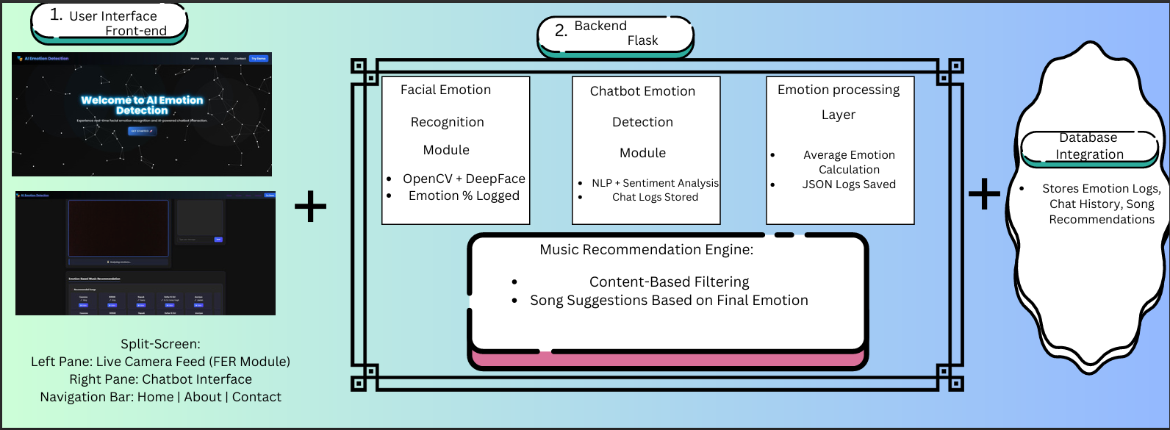

**1. Introduction**

Welcome to our AI-Based Emotion Detection & Music Recommendation System[Y.M.I.R].

By accessing or using our Service, you (“User”) agree to comply with and be bound by the following Terms & Conditions, Privacy Policy, and Ethical Guidelines. Please read them carefully. If you do not agree to these terms, you must discontinue use immediately.

**2. Data Collection & Privacy Policy**

**2.1 Personal Data Collection**  
Our Service collects certain personal data to provide an enhanced and personalized experience:

* Real-time facial emotion data via webcam (no images or videos stored permanently).
* Text-based inputs from chatbot conversations.
* Chat history logs (stored temporarily and anonymized).
* Basic usage statistics (time spent, session duration).

**2.2 Data Usage**  
The collected data is used strictly for:

* Analyzing emotions to personalize song recommendations.
* Improving chatbot interaction quality.
* Enhancing system performance and accuracy.

We **DO NOT sell, rent, or share your personal data** with third parties without explicit consent, except as required by law.

**2.3 Data Storage & Security**  
All user data is stored securely on encrypted servers and is regularly purged after a defined retention period (e.g., 30 days). Security measures like HTTPS protocols, encryption, and restricted access are implemented to prevent unauthorized access.

**2.4 User Consent**  
By using our Service, you consent to:

* Accessing your camera for emotion detection.
* Analyzing text-based input.
* Temporary storage and processing of your data.

**3. User Responsibilities & Ethical Use**

* Users must be at least 14 years old or have parental/guardian consent.
* Users agree to use the system ethically, refraining from sharing harmful, offensive, or illegal content.
* The Service is intended solely for personal, non-commercial, educational, or entertainment purposes.
* Users are prohibited from attempting to reverse-engineer, hack, or misuse the system in any form.

**4. Limitations & Disclaimers**

* **Accuracy Disclaimer:** While our AI models aim for high accuracy in emotion detection, no guarantee is made regarding 100% correct classification.
* **Not Medical Advice:** Our Service is not a substitute for professional psychological or medical advice. The mood recommendations are for entertainment purposes only.
* **Third-Party Links:** Our platform may display links to third-party music apps or services. We are not responsible for their content, privacy policies, or practices.

**5. Intellectual Property Rights**

All software, designs, content, and algorithms used in this Service are the exclusive intellectual property of the developers. Users may not copy, modify, distribute, or create derivative works without prior written permission.

**6. Legal Compliance**

We comply with applicable data protection laws, including:

* The **Information Technology (Reasonable Security Practices and Procedures and Sensitive Personal Data or Information) Rules, 2011** (India).
* Local privacy and cybersecurity regulations.

**7. Termination of Access**

We reserve the right to suspend or terminate user access without notice if:

* Any misuse, unauthorized access attempt, or unethical behaviour is detected.
* Legal obligations or privacy violations occur.

**8. Changes to Terms**

We may revise these Terms & Conditions at any time. Users will be notified of significant updates via the platform. Continued use after such changes constitutes agreement to the updated terms.

**9. Consent Clause**

**By clicking “Agree” or continuing to use our Service, you confirm that you:**

* Have read, understood, and accepted these Terms & Conditions and Privacy Policy.
* Consent to the collection, processing, and temporary storage of your data as outlined.
* Agree to abide by ethical usage, legal compliance, and our intellectual property guidelines.

**Feasibility Study**

The AI-based Emotion Detection and Music Recommendation System is highly feasible both technically and commercially. From a technical standpoint, it helps open-source technologies such as DeepFace, OpenCV, Flask, and NLP-based chatbots or API based chatbots, ensuring minimal development costs. The system is designed to run efficiently on standard hardware and free-tier cloud services, making it cost-effective and scalable for broader deployment.

**Business Context**

From a business context, there is a growing demand for **personalized digital experiences**, particularly in entertainment and wellness sectors. Platforms like Spotify and YouTube offer algorithmic recommendations, but few provide real-time mood-based song suggestions enhanced by actual emotion recognition through facial analysis and chatbot interaction. Our product fills this gap, making itself as a unique, interactive, emotion-aware music service.

**Monetization Strategies**

1. **Premium Model:** Offer basic emotion-based song recommendations for free while charging for premium features such as ad-free experience, advanced personalization, playlist creation, and mood tracking analytics.
2. **Subscription Model:** Monthly or annual subscription plans offering exclusive content, priority features, or integrations with popular music platforms like Spotify or Apple Music.
3. **B2B Licensing:** License the emotion detection API to mental health apps, gaming companies, or music streaming platforms.
4. **Advertisement Revenue:** Allow mood-targeted advertising for brands based on detected emotions.

**Opportunity Analysis**

The emotional AI market is expected to grow significantly, valued at over $25 billion by 2025. With increasing emphasis on mental well-being, personalized content, and AI-driven recommendations, there is an opportunity to integrate this system into sectors like digital wellness, music streaming, gaming, and virtual therapy.

Early adoption can establish strong market positioning and open up partnerships with larger entertainment platforms, giving a competitive edge in the emotion-driven user experience space.

As per the Organic COCOMO model, our AI-Based Emotion Detection & Music Recommendation System (estimated at 7 KLOC) requires approximately **18 Person-Months** and around **10-12 months of development** with a small team of 2-3 members.

The integration of open-source technologies like **DeepFace, OpenCV, Flask, and TensorFlow** ensures zero licensing costs.

The development and deployment can be effectively managed using **free-tier cloud infrastructure (AWS/GCP)**, with backend implementation in Flask.

Hardware costs for high-performance laptops/servers are estimated at **₹1,00,000 - ₹1,20,000**. Database management (using Firebase/SQLite) would cost around **₹3,000 - ₹10,000/month**.

Cloud hosting within the free tier would incur additional costs of **₹10,000 - ₹20,000** annually. Maintenance, UI enhancements, and periodic updates may require **₹30,000 - ₹50,000**.

Miscellaneous expenses such as internet, electricity, and testing tools are projected at **₹10,000 - ₹25,000**.  
**Total Estimated Cost: ₹1,25,000 - ₹2,00,000 over 3 years.**  
The system design and architecture phase spans 1 month, integration & testing takes 6-7 months, while deployment and user testing continue over 3-4 months to ensure smooth functionality.

<https://github.com/pallav110/DTI-AND-AI-PROJECT>

Week 1:

Researched about the problem and dataset and came across live emotion recognition , text based emotion recognition , music recommendation

Did my research about these three individual projects and worked on them separately .Decided to combine it and prepared the dataset by scraping spotify using spotipy api.

Week 2:

Started developing the mood FER[Facial emotion recognition] using FER-NET but then went with deepface a pre built library . Set up OpenCV library for capturing real time video and integrated with DeepFace for emotion detection. Focused on detecting basic emotions and set face and hand and body mesh using mediapipe

Week 3:

Continued to refine the FER model. Improved the speed and accuracy and real time performance. Had an idea of storing the emotions in a JSON file for later processing and move on to the chatbot system.

Week4:

Shifted My focus on building the AI ChatBot . First designed a basic chatbot structure using NLP techniques for text-based emotion classification but then went on ahead and used GROQ's Api and 4 other pre built model for mood based text-classification to correctly predict the mood. Had an idea of storing the chatlog in JSON format along with the average mood stored there and continously updated.

Week5:

Began integrating the results of both the JSON file and tried to map the emotions , and store it in a complete other JSON file for further processing

Week6:

Started to work on music recommendation system using ensemble learning. We took around 15 models and chose 5 best to combine it into a ensemble model. Then , after we got the ensemble model we went on to integrate the numerical values with the musical features and combined them to give final recommendation of music.

Week7:

Started integrating both the FER and chatbot modules. Set up a split-screen web interface with Flask where both modules run simultaneously. Ensured real-time emotion logs from both systems are captured correctly and ready for combined processing. Continued the integration, connecting the backend logic to average emotions from both facial recognition and chatbot. Linked this output to the music recommendation engine. Displayed recommended songs dynamically on the interface based on detected emotions.

Week8:

Completed full integration. Ensured all modules (FER, chatbot, emotion processing, and music recommendation) work together seamlessly. Conducted initial rounds of user testing to identify any glitches and made backend improvements, for smoother performance. Focused on end-to-end testing. Optimized user interface design , improved design elements like loading animations and navigation. Fixed minor bugs, enhanced system responsiveness, and ensured correct logging of user data, emotion records, and song recommendations.

Week 9:

Tested system’s stability under high usage and different user inputs. Need to start preparing a detailed user documentation with architecture diagrams.

Week 10:

Add manual mood input option for users. Include playlist creation and dark mode features. Optimize frontend responsiveness for mobile devices. Conduct stress testing and fine-tune backend processing to handle different data efficiently.

Week 11:

Run extended user testing with university peers. Gather structured feedback through surveys. Improve system based on feedback, focusing on usability, stability, and interface. Ensure backend logs, emotion averages, and recommendations are error-free.

Week 12:

Finalize and clean the project code. Complete documentation, prepare demo video, and ensure all diagrams are updated. Conduct final presentation preparation. Submit complete project package including report, code, logs, and demo.

<https://www.linkedin.com/posts/pallav-sharma-3a474727b_the-design-activity-7307022451375255552-XOUy?utm_source=share&utm_medium=member_desktop&rcm=ACoAAERGeWwBQY8YRsc8CLq4KPXssXp1cxj2ddE>

Yes , I do believe my project is applicable for a patent.

The integration of real-time facial recognition with a chatbot-based emotion analysis system , combined with a recommendation system presents a unique , user-curated solution. While individual tech. like emotion detection , chatbot and music recommendation exists ,all of them combined together with a good User interface doesn't and this creates a novel approach of the problem.

We plan to proceed by first conducting a search for any possible existing project like ours . Then we will document the system design , functions , and other elements clearly. We will consult out universities startup cell to look into it and assist us in filling up a patent.

Name: Jatin Singhal

Enrolment # : E22CSEU0052

Email: E22CSEU0052@bennett.edu.in

Mobile #: +91 90583 88839

Description of Feedback:

The system is very impressive and easy to use. I liked how smoothly both the facial emotion recognition and chatbot work together. The song recommendation feature based on emotions is unique. I would suggest adding an option to customize song genres according to user preferences

Name: Sakshi Jain

Enrollment #: E21CSEU0983

Email: E21CSEU0983@bennett.edu.in

Mobile #: +91 79832 05550

Description of Feedback:

I found it interesting, The idea of suggesting songs based on live emotions is new. improvements like faster loading times would make it even more nice.

Name: Divyansh Rana

Enrollment #: E22CSEU0645

Email: E22CSEU0645@bennett.edu.in

Mobile #: +91 89205 05011

Description of Feedback:

The integration of facial emotion recognition with a chatbot feels good. Music recommendations were relevant to me. Adding a user mood history could make the system more good.